Pre-authorized online resources:
For one of your three sources, you may use one of the following sources, without having to use the CRAAP test:
- Biography.com
- Biography in Context through Inspire
The following is an explanation of how to use each of these sources.
Biography.com
- Type the web address into the browser (http://www.biography.com)
- The following page should appear (although the featured articles may differ each day).
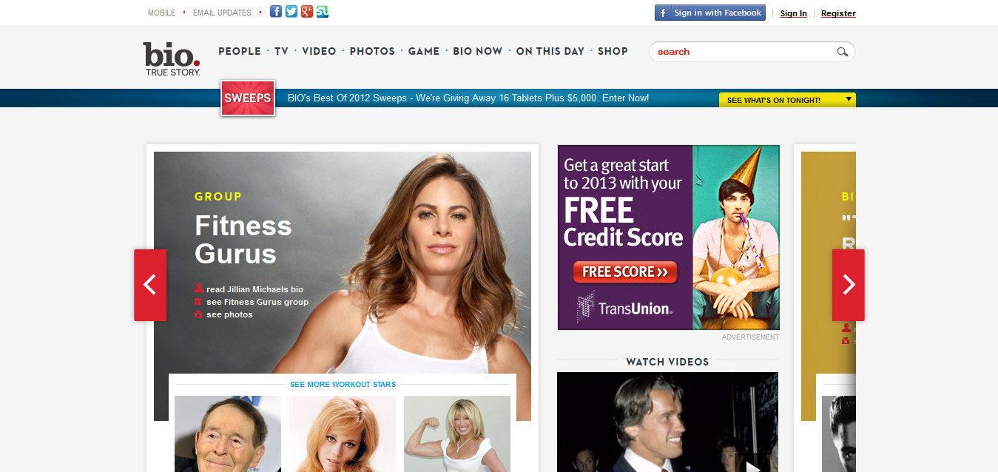
You can see that there are advertisements on this page, but they are clearly labeled as advertisements.
- There is a search bar in the upper right-hand corner of the page. Begin typing your famous person’s name and it should start dropping down suggestions.

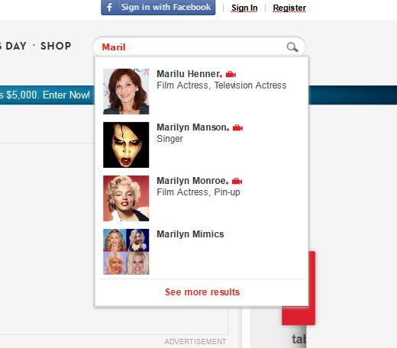
- Click on the person you are looking for.
- On this page you will find photos, videos, a “best known for” (this would be good for your poem), as well as biographical information.
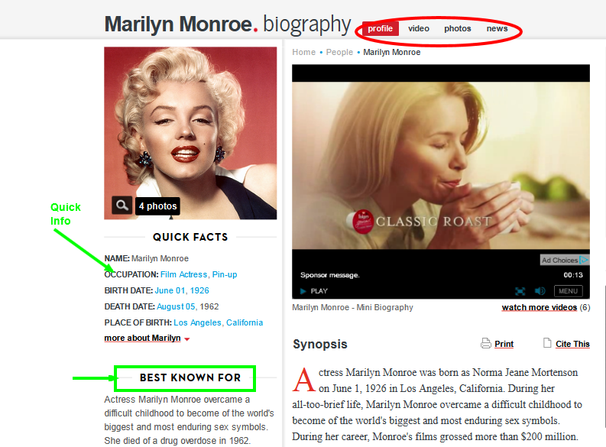
Biography in Context
- In your browser’s address bar, type in http://www.inspire.net (Inspire is a free service for Indiana residents through the state library. If you are using this at home and live close to the Ohio line, they may ask you to register using your Indiana address and they will generate a password for you. They will also send you a postcard in the mail. Of course, before registering for this, or any site, please talk to your parents and explain what it is. My internet service comes from Wabash and we get our signal bounced off of Coopers in Fort Recovery, so I had to do this in order to use this site at home.)
- The following page will appear:
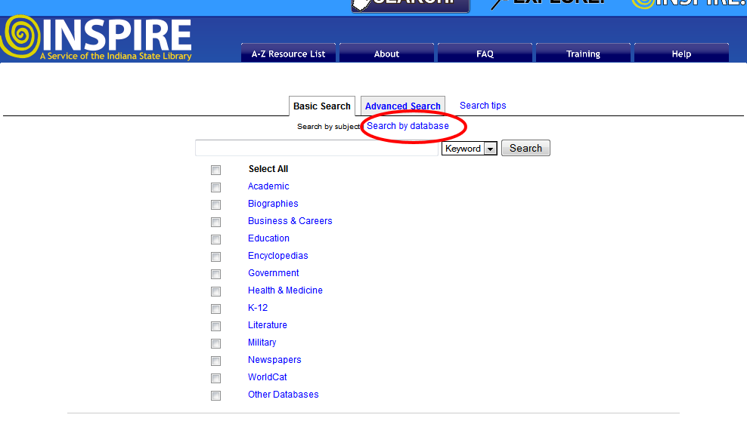
- We are going to click the link circled in the above picture that reads “Search by database”.
- On this page, we can do one of two things. You can type your famous person’s name in to the Search Box, click on the box next to “Biography in Context”, then click “Search”. OR you can click on the words “Biography in Context” and go directly to that database. See the illustration below.
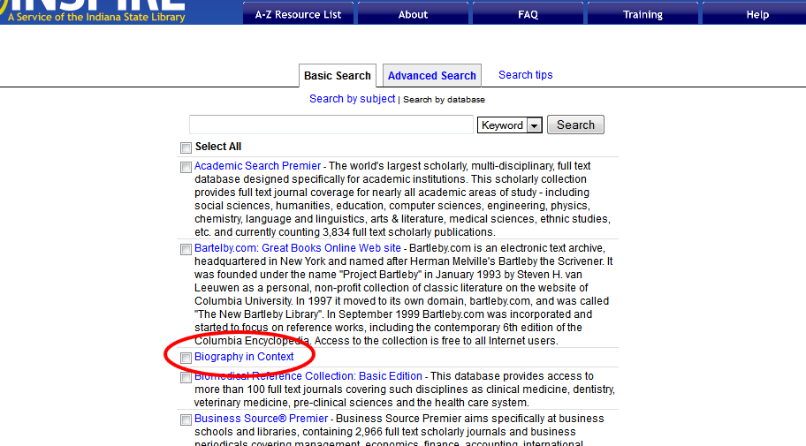
- When on the “Biography in Context” page, type in your famous person’s name and you will get a similar drop down list to the one on Biography.com. You will notice, however, that on the main screen, there are no advertisements as this is a real academic database rather than a site for the biography channel.
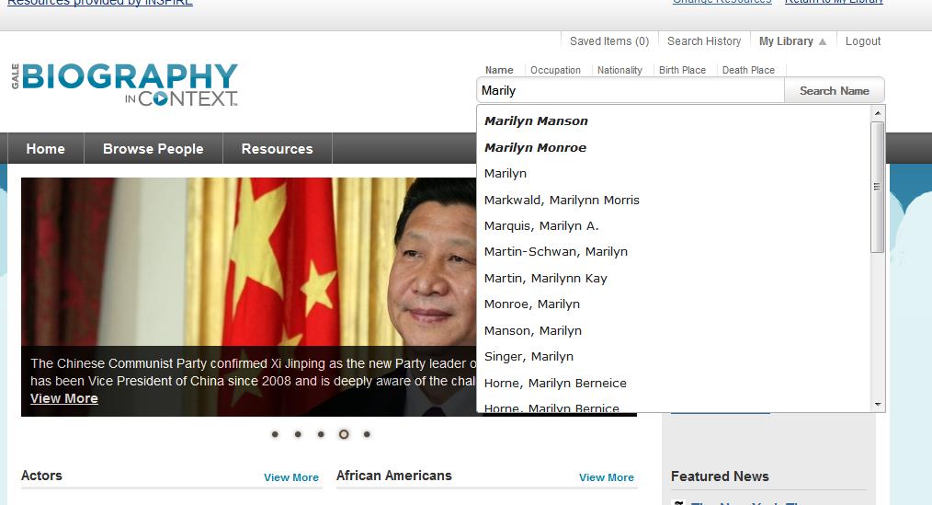

- On this page, you will notice a box on the right-hand side where you can explore articles from many different resources. Let’s stay away from the “websites” portion, but links in the “References” and “Academic Journals” would be excellent resources. Also, images from this site would be good as well. Remember, if you take notes from an article, you need to write down all the information for that article. If you write down information from 6 articles on this site, you must have 6 entries on your “Works Cited” page for your report.
